BUSINESS CONTINUITY PLAN

Role | Name | Signature / Date
Author | Deepak Menon | 4/13/19
Reviewer | Nagoor Inaganti | 4/15/19
Approver | Nagoor Inaganti | 4/15/19

Copyright Information
The information contained in this document is the exclusive property of Tanvi IT Solutions Inc. This Project /Work is protected, and no part of this Project /Work may be reproduced or transmitted in any form or by any means, electronic or mechanical, including photocopying and recording, or by any information storage or retrieval system, except as expressly permitted in writing by Tanvi IT Solutions Inc.

Revision History
Revision #  (x.yy) | Revision Date  (dd-mm-yyyy) | Description of Change | Author | Reviewer | Approver
1.1 | 13-04-2019 | Baseline Version | Deepak Menon | Nagoor Inaganti | Nagoor Inaganti

Table of Contents
1 Objective 4
2 Scope 4
3 Input 4
4 Output 4
5 Procedure 4

Objective
Business continuity planning (BCP) is the process involved in creating a system of prevention and recovery from potential threats to Tanvi IT. The plan ensures that personnel and assets are protected and can function quickly in the event of a disaster. The BCP is generally conceived in advance and involves input from key stakeholders and personnel.

Scope
The scope of this document is to define any and all risks that can affect the operations of Tanvi IT, making it an important part of the organization's risk management strategy.

Input
- Risk Management

Output

- Risk Mitigation Plan
- Service Continuity

Procedure
Business Continuity Plan is developed by using the following steps:
- Business Impact Analysis: In order to identify functions and related resources that are time sensitive.
- Recovery: Tanvi IT identifies and implements steps to recover critical business functions.
- Organization: A continuity team is created. This team will devise a plan to manage the disruption.

Threats and Mitigation
Threats and risks include
- Competitive risks
- Operational risks
- Legal risks
- Strategic Business risks
- Natural disasters like fire, floods, earthquakes.

Premises and infrastructure
Types of threat | Consequences | Countermeasures
Natural Disaster | Damage to infrastructure and employee | Training to employees on disaster recovery, evacuation pathway.

Computer and telecommunications equipment

Risks of equipment becoming definitively unavailable
Types of threat | Consequences | Countermeasures
Cyber Security | Disrupt phone, computer networks | Wifi Protected Access  Virus Scanner

Operating systems, applications, data and flow

Risk of becoming definitively unavailable
Types of threat | Consequences | Countermeasures
Out of date plug-ins | Security Vulnerability | Update the plug-ins

Services, supplies and outside contractors

Risks of becoming temporarily unavailable
Types of threat | Consequences | Countermeasures
Legal Compliance Risk | Disruption of business | Establishing clear documentation and communication about the compliances.

Human resources

Risks of becoming definitively unavailable
Types of threat | Consequences | Countermeasures
Termination of employment | Requirement to be fulfilled | Maintain candidates in the pipeline.

Risks of becoming temporarily unavailable
Types of threat | Consequences | Countermeasures
Employee on leave of absence | Temporary shortage of resource | Reassign the roles and responsibilities among the available resources.

Continuity Plan
Based on the risk analysis and counter measures taken to mitigate the risks Tanvi IT has identified the below continuity plan:
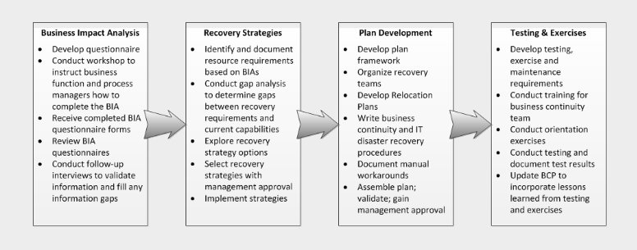

Crisis Management Team (CMT):

Crisis Management Team includes:
Crisis Manager (Project Manager)

Human Resource Advisor
Legal Advisor
Business Unit Advisor
Subject Matter Expert.

